**Paper Review**

**of *Security Risks in Deep Learning Implementations***

XXX 20181703XXX

This paper discloses the presence of the vulnerabilities in prevalent deep learning frameworks, and appeals the relevant community to improve the security of deep learning frameworks.

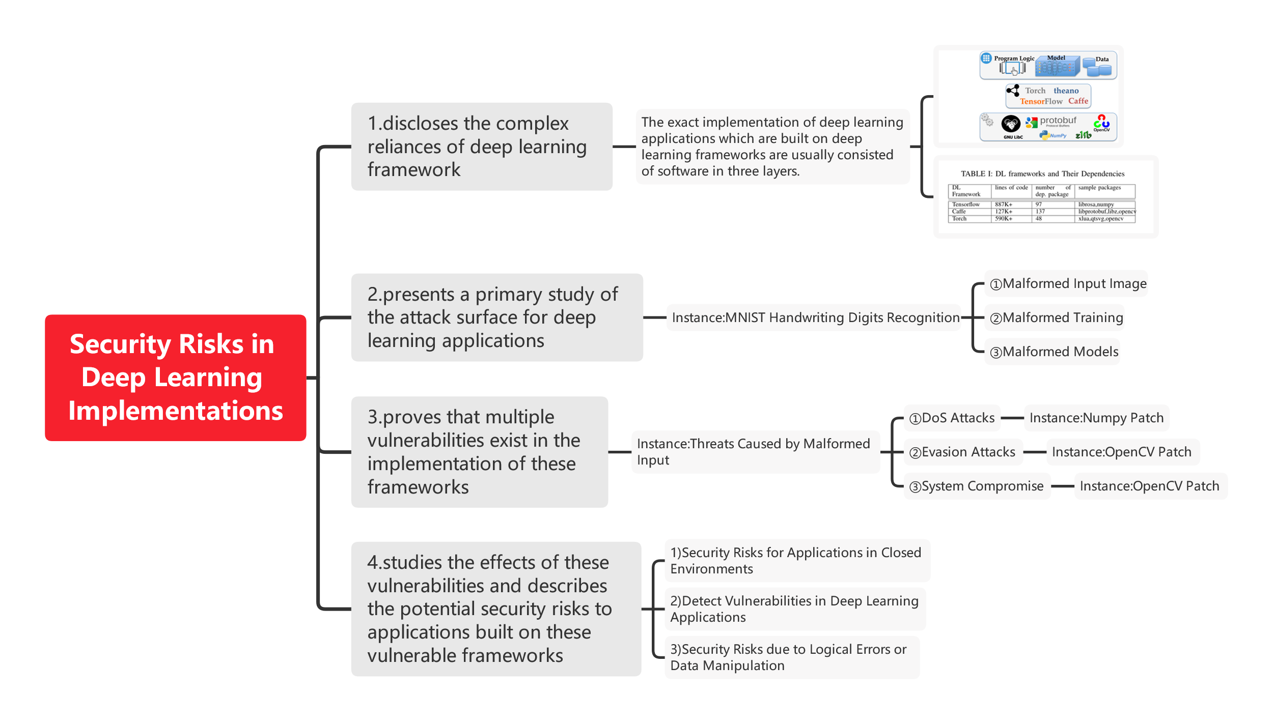

But we could still find out some limitations in the paper. For example, the paper did not give enough instance. Instead, the paper is more like in a concept aspect to discuss its viewpoints, causing the readers not knowing what exactly to do.

I deem that the paper has a high study value, which enlighten readers that they should be cautious about the risks in the deep learning framework. Study is important, but the insurance of security of the model is more important. Otherwise, one could easily bypass his application.